Тема раздела: Здоровый образ жизни.
Тема урока: Радуга овощей и фруктов.
Учебная цель: Учитель(У) - Развитие умений поискового чтения.
Систематизация ЛЕ по теме «Овощи, фрукты»
Обучающиеся(О) – Выяснить, как фрукты и овощи влияют на здоровье человека, используя информацию из аутентичной статьи.
Оборудование: интерактивная доска (программа Active Inspire), дидактические карточки (приложение 1- 6)
Ход урока
1. Организационный этап. Актуализация ранее изученного материала.
Цель: У - настроить на общение на английском языке, организовать актуализацию ранее изученного материала.
О – включиться в иноязычное общение, осуществлять актуализацию ранее изученного материала.
У: Dear friends! I`m glad to see you. Are you ready to start our lesson?
Remember the things we discussed last lesson. (We spoke about good and bad health habits and how to keep fit)
What about you? Do you try to keep fit? I what way?
Do you go in for sport? Do you smoke? Do you …? (на доске – интерактивные карточки, приложение1)

2. Целеполагание, мотивация деятельности (фронтальная работа)
Цель : У – поставить познавательную задачу (выяснить, как овощи и фрукты определённого цвета влияют на наш организм; составить список полезных для себя продуктов), мотивировать учебную деятельность.
О– сформулировать (принять) тему и познавательную задачу урока (выяснить, как овощи и фрукты определённого цвета влияют на наш организм; составить список полезных для себя продуктов).
У: I also try to keep fit. For example, I don`t smoke, don`t drink alcohol. I try to be positive. I go in for sport and care of food I eat. I often read books or articles about healthy way of life.
Recently I`ve read a very interesting article in the net. I was so impressed that I`ve gone to the shop and bought following foods (Look at the board – флипчарт 1, приложение 2).What do you see? What`s common in these products? (They are fruit and vegetables; they are in green colour)
What do you think why I`ve bought these green foods? Suggest the title of article I`ve read? (The title of the article is «RAINBOW OF FRUIT AND VEGETABLES». You can read in the article how the colour of fruit and vegetables influences on our body. For example, I have some problems with my eyes, I often feel nervous and tired, so I`ve chosen green foods. And what about you? Do you want to know how the colour of fruit and vegetables influences on our body and what foods you need?
We`ll read the article to answer these questions.
3. Основной этап. Работа с текстом.
Цель: У – Развитие умений чтения с поиском конкретной информации.
О – Познакомиться с информацией по теме.
3.1. Предтекстовый этап.
1) Работа с ЛЕ (фронтальная работа)
Цель: Снятие языковых трудностей. Систематизация ЛЕ по теме «Овощи и фрукты».
У: I`m giving the article. But it is an original text from the English website, so it contains a lot of unknown words and word combinations, for example the names of foods. Some of them you`ve learnt at school, but you need to remember them.
Выполнение задания на флипчарте 2, приложение 2 (Классификация слов).
У: Come to the board! You can see the names of different fruits (in blue colour), vegetables (in green colour) and berries (in red colour). Classify them into 6 columns after their colour. If you don`t know the meaning of the word, you can click on it and find the help.
2) Предвосхищение содержания текста.
Цель: Снятие языковых трудностей – актуализация пассивного словаря, обобщение имеющегося опыта о влиянии фруктов и овощей на организм человека.
Выполнение задания на флипчарте 3, приложение 2 (фронтальная работа)
У:Before reading predict how the colour of fruit and vegetables influences on our body.
Predict what foods … (флипчарт 3).
3.2. Текстовый этап (работа в группе\паре).
Цель: У – Развитие умений поискового чтения.
О – Знакомство с текстом, нахождение конкретной информации об овощах и фруктах определённого цвета (приложение 3).
У: Read the article to check your predictions. Work in four groups. Read about the foods of …colour (it is underlined with a marker). Then match the information on the worksheet 1 (приложение 4, Worksheet task 1).
3.3. Послетекстовый этап.
Цель: У – Развитие умений поискового чтения, тренировка ЛЕ по теме «Овощи и фрукты»в устной и письменной речи.
О - Систематизация информации по прочитанному тексту.
1) Выполнение задания на флипчарте 3 и листе 1, приложения 3, 4(фронтальная работа)
У: You`ve learnt the information. What can you say about your colour of foods? Come to the board and correct our predictions. Match the information on the worksheet 1.
2) Выполнение заданий на карточках (Worksheet task 2, приложение 4)(фронтальная работа), проверка задания на флипчартах 4-10, приложение 3.
У: Let`s summary the information and say how the colour of fruit and vegetables function in certain situations..
Fill the worksheet 2 with different foods. Work in pairs or alone.
…Say what food you need if …. (флипчарты 4-10).

4. Заключительныйэтап.
Цель: У - установить соответствие полученного результата поставленной цели (выяснить, как овощи и фрукты определённого цвета влияют на наш организм; составить список полезных для себя продуктов), дать инструкции по выполнению самостоятельной работы по тексту.
О – проанализироватьсоответствие полученного результата поставленной цели (выяснить, как овощи и фрукты определённого цвета влияют на наш организм; составить список полезных для себя продуктов), спланировать дальнейшую работу над текстом.
1) Рефлексия.
У:Well done!
- Did you like the article?
- Was the information interesting for you?
- Have you learnt much about fruit and vegetables today?
- Are you ready to eat the necessary fruit and vegetables to avoid the problems with your health?
Can you say what foods you need at all? (I need…to..).
2) Домашнее задание.
У: (I see you`ve learnt the information what foods are good for you, but…; you are not to say what foods are good for you, so…)I offer you to read more information about different foods on the following websites…Read and make the list of foods you need at all. (флипчарт 5, приложение 3)

5. Дополнительный этап. Просмотр видеоролика с песней «Радуга фруктов и овощей»
Цель: У – расширение страноведческого кругозора (творческая деятельность музыканта ДжейМанкита, популяризация здорового образа жизни в США), мотивировать деятельность для внеклассной работы (поэтический перевод).
У: The things connected with healthy way of life are interested by many people in English speaking countries and especially in the United States. Why? (A lot of Americans are overweight), so there are people who popularize healthy habits and healthy food. For example I`ve found a very interesting website called «RAINBOW OF FRUITS AND VEGETABLES». This website presents the American singer, composer and artist Jay Mankita. In the USA he is known as a musician making shows about healthy way of life for children, teens and grown-ups.
Let`s watch the video and listen to one of his best song. You can use the help and sing the song with Mankita.(флипчарт 6, приложение 5)
Is the song great? Why? (it tells about the great role of fruit and vegetables; I`m sure it influences on children`s mind;it`s energetic and positive). I `ve got an idea to translate the song in Russian. OK? Have you a wish to do it? (Who`ll try to translate it?)

I thank you for your work. The lesson is over. Good bye!

Приложение 1

Eating fruit and vegetables
Smoking
Eating homemade food
Drinking alcohol
Spending much time on the computer
Sleeping not less than eight hours a day
Eating a variety of foods
Skipping meals
Eating fast-food
Watching TV too much
Taking vitamins
Spending much time out-of-doors
Going in for sport
Limiting TV and computer time
Drinking a lot of mineral water
Having the latest meal tonight
Being positive

Приложение 2

Изображения флипчартов, подготовленных к уроку

Флипчарт 1 (к этапу 2)

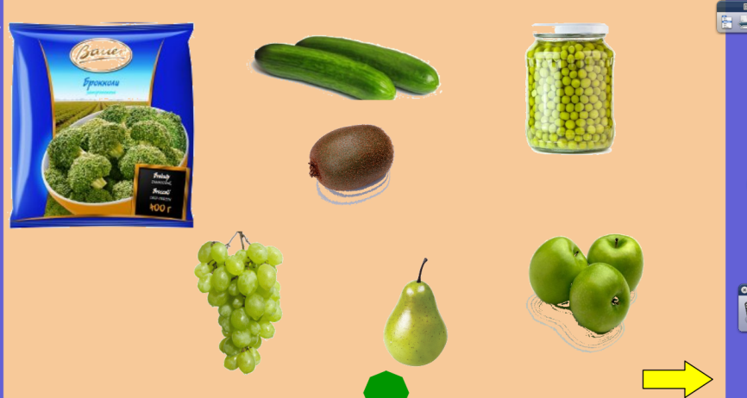

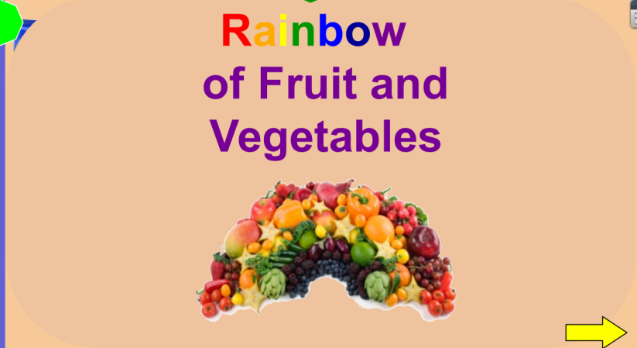

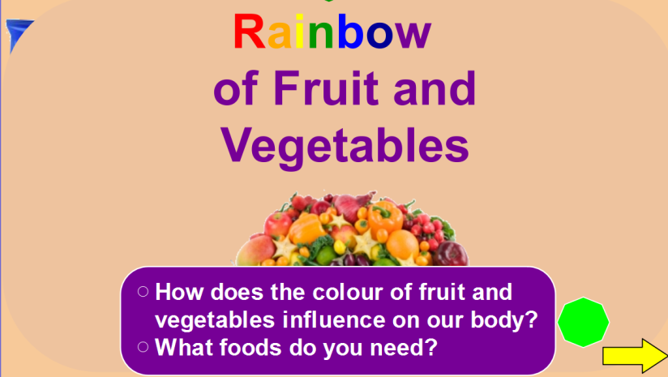

Флипчарт 2 ( к этапу 3.1\1)

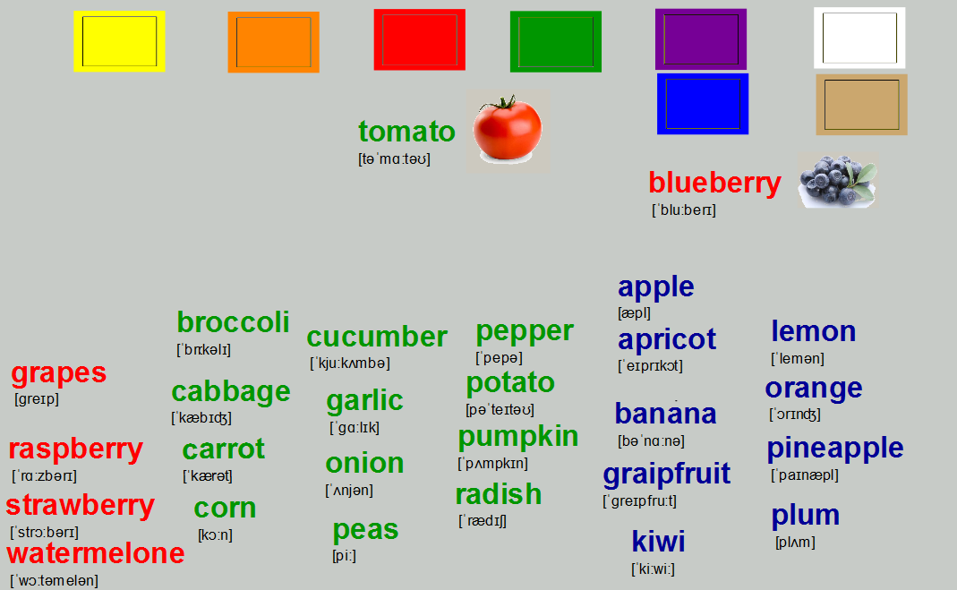

Флипчарт 3 (этап 3.1\2)

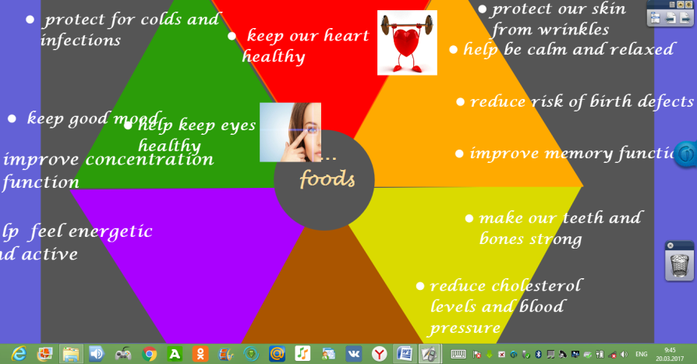

Флипчарты 4-10 (этап 3.3)
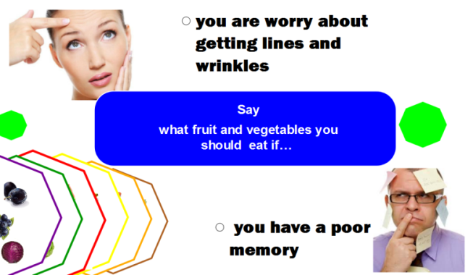
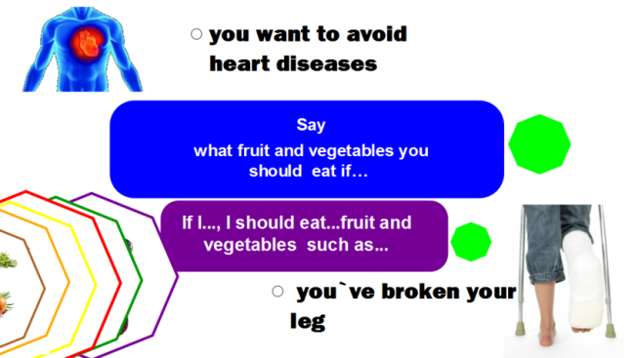

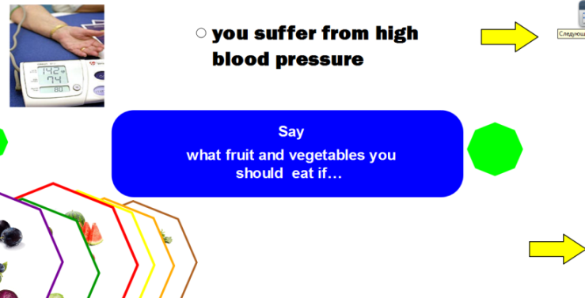
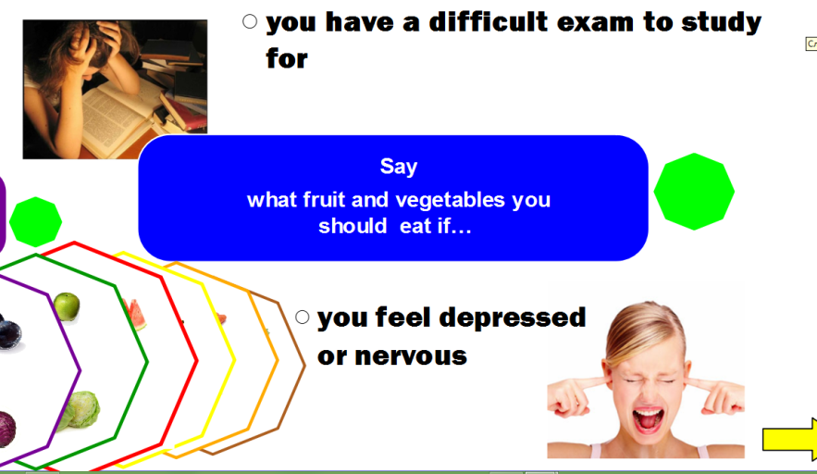

Флипчарт 5 (этап 4\2)

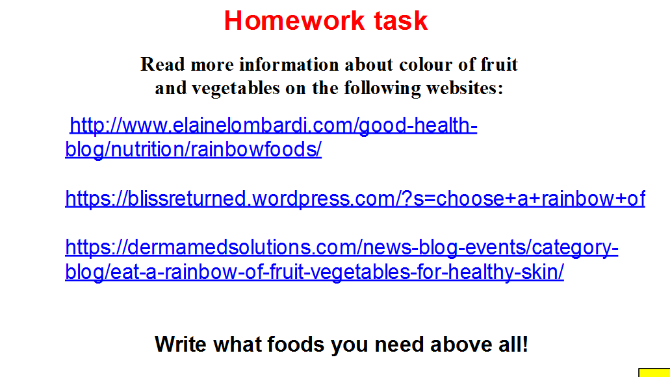

Флипчарт 6

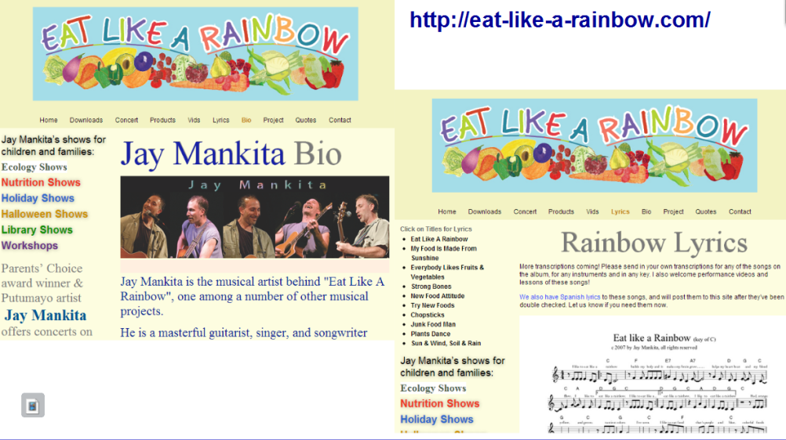

Приложение 3

Rainbow
of Fruit and Vegetables

Fruit and vegetables come in a variety of colors. They are loaded with essential vitamins and minerals, but often contain additional phytonutrients that may provide additional health benefits.

Why eat red?
Many red fruits and vegetables are high in vitamin C, like grapefruit, raspberries, radishes, red bell peppers, strawberries, tomatoes and watermelon. Vitamin C is important for the body and prevents skin ageing.
Red fruits and vegetables also contain lycopene and anthocyanins that have a role to play in cancer prevention and treatment. Lycopene in foods containing cooked tomatoes, such as spaghetti sauce. Anthocyanins are in strawberries, raspberries, red grapes and other fruits and vegetables. They are associated with heart health. So Red foods get you moving and can keep older people active for longer.

Why eat orange and yellow?
Orange/yellow fruits and vegetables are usually colored by natural plant pigments called “carotenoids.” This substance promotes UV protection to keep our skin healthy and can protect the body from infections improving immune system function.
Beta-carotene in sweet potatoes, pumpkins and carrots is converted to vitamin A, which helps maintain healthy eyes. Citrus fruits like oranges are an excellent source of vitamin C and folate, a B vitamin that helps reduce risk of birth defects. Yellow food are natural`s way of helping us to stay healthy and optimistic. Eat a banana and you`ll fill a bit better.
Orange foods are brain food. They help you keep your mind on things and really improve your power of concentration.

Why Eat Green?
Green fruits and vegetables are colored by natural plant pigment called “chlorophyll.” Some members of the green group, including spinach, green peppers, peas, cucumber and celery, contain lutein. Lutein works with another chemical zeaxanthin to help keep eyes healthy. Together, these chemicals may help reduce risk of cataracts and age-related macular degeneration, which can lead to blindness if untreated.
Dark green vegetables like collard greens and spinach contain calcium for strong bones. Spinach also contains iron to keep us feeling energized and strong.
Green foods are also great when you want to relax, calm yourself down or keep your emotions under control.

Why Eat Blue and Purple?
Blue/purple fruits and vegetables are colored by natural plant pigments called “anthocyanins.” Anthocyanins in blueberries and grapes act as powerful antioxidants that protect cells from damage. They may help reduce risk of cancer and heart disease. Other studies have shown that eating more blueberries is linked with improved memory function and healthy aging.
Why Eat White?
White fruits and vegetables are colored by pigments called “anthoxanthins.” They may contain health-promoting chemicals such as allicin, which may help lower cholesterol and blood pressure. Some members of the white group, such as bananas and potatoes, are good sources of the mineral potassium, too.
http://www.chathamnc.org/

Приложение 4

Worksheet task 1

Match how the colour of fruit and vegetables influences on our body.
.
1. Red foods  2. Orange\yellow foods  3. Green foods  4. Blue\Purple foods  5. White foods | help feel energetic and active  improve concentration function  stimulate immune system, protect for colds and infections  help keep eyes healthy  are important for our nervous system, help be calm and relaxed  are important to keep good mood  make our teeth and bones strong  prevent skin aging  reduce risk of birth defects  reduce risk of cancer  improve memory function  help keep our heart healthy  reduce cholesterol levels and blood pressure

Worksheet task2
Write
What fruit and vegetables you should eat if…
- you have a poor memory?
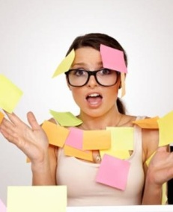
______________________________________
______________________________________
______________________________________
______________________________________
______________________________________
______________________________________
______________________________________

Worksheet task2
Write
whatfruit and vegetables you should eat if…
- you have a cold or the flu?
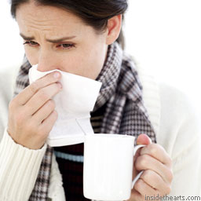
________________________________________
________________________________________
________________________________________
________________________________________
________________________________________
________________________________________
________________________________________

Worksheet task2
Write
whatfruit and vegetables you should eat if…
- you often feel tired?
____________________________________
____________________________________
____________________________________
____________________________________
____________________________________
____________________________________
____________________________________

Worksheet task2
Write
whatfruit and vegetables you should eat if…
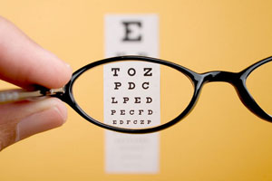
- you are shortsighted?
______________________________________________
______________________________________________
______________________________________________
______________________________________________
______________________________________________
_____________________________________________

Worksheet task2
Write
What fruit and vegetables you should eat if…
- You feel depressed or nervous?
_________________________________________ __________________________________________
__________________________________________
__________________________________________
__________________________________________
__________________________________________
__________________________________________

Worksheet task2
Write
whatfruit and vegetables you should eat if…
- you`ve broken your leg?
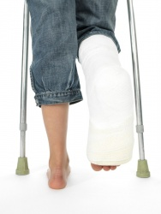
___________________________________________
___________________________________________
___________________________________________
___________________________________________
___________________________________________
___________________________________________
___________________________________________

Worksheet task2
Write
whatfruit and vegetables you should eat if…
- you have a difficult exam to study for?
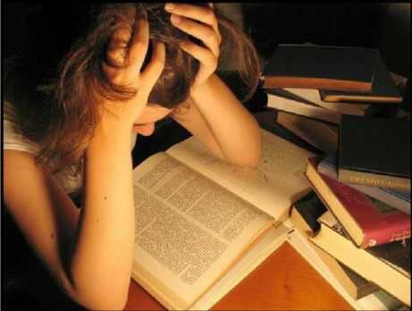
______________________________________
______________________________________
______________________________________
______________________________________
______________________________________
______________________________________
______________________________________

Worksheet task2
Write
whatfruit and vegetables you should eat if…
- you are worry about getting lines and wrinkles
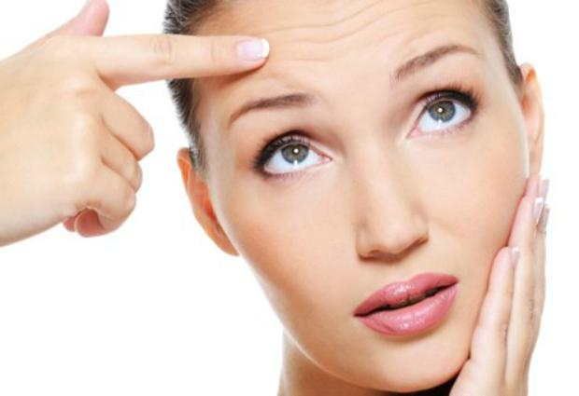
_________________________________________
_________________________________________
_________________________________________
_________________________________________
_________________________________________
_________________________________________

Worksheet task2
Write
whatfruit and vegetables you should eat if…
- you are pregnant and worry about your baby`s health
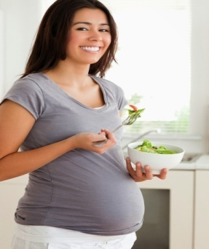
_________________________________________________
_________________________________________________
_________________________________________________
_________________________________________________
_________________________________________________
_________________________________________________
_________________________________________________

Worksheet task2
Write
whatfruit and vegetables you should eat if…
- you suffer from high blood pressure
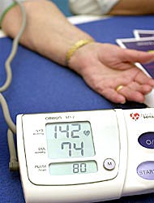
_________________________________________________
_________________________________________________
__________________________________________________
__________________________________________________
__________________________________________________
__________________________________________________

Worksheet task2
Write
whatfruit and vegetables you should eat if…
- you want to reduce risk of cancer
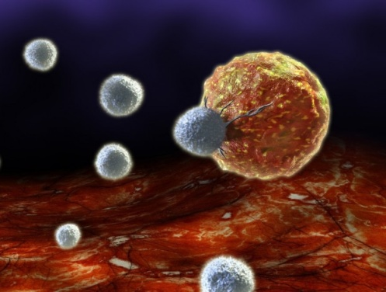
________________________________________
________________________________________
________________________________________
________________________________________
________________________________________
________________________________________
________________________________________

Worksheet task2
Write
whatfruit and vegetables you should eat if…
- you want to avoid heart diseases
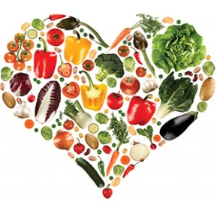
____________________________________________________
____________________________________________________
____________________________________________________
____________________________________________________
____________________________________________________
____________________________________________________

Worksheet task2
Write
whatfruit and vegetables you should eat if…
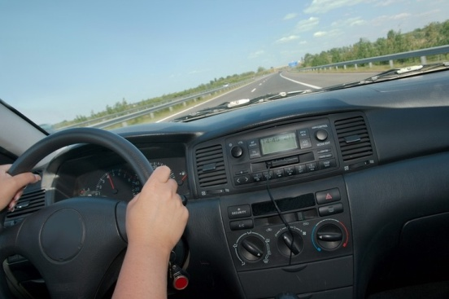
- you drive a car
_____________________________________________
_____________________________________________
_____________________________________________
_____________________________________________
_____________________________________________
_____________________________________________

Приложение 5

Jay Mankita is the musical artist behind "Eat Like A Rainbow", one among a number of other musical projects.
He is a masterful guitarist, singer, and songwriter who for the past 30 years has presented thousands of concerts for adults and for children.
On the website http://eat-like-a-rainbow.com/ you can listen to his lyrics like «Eat like a Rainbow», «My food is made from Sunshine», «Everybody likes fruit and vegetables», «Junk food man» etc. and watch some videos of his concerts.

Eat Like A Rainbow
Jay Mankita c 2005
I like to eat like a rainbow:
Builds my body and it makes my brain grow,
Helps my heart beat and my blood flow,
I like to eat like a rainbow!
Red, orange, yellow, green -
The tastiest colors I've ever seen.
I like to eat food that's purple and blue,
Colorful foods are healthier too
Colorful food makes a colorful meal
And that really colors the way that I feel.
I'm livin' in a colorful way,
I eat like a rainbow every day
A rainbow of light from the sun and the rain,
My colorful garden is a rainbow again.
I eat like a rainbow; my colors shine through
The words that I say, and the things that I do.

Приложение 6

Конспект и анализ урока на английском языке

Lesson Plan
developed by Irina Ilina, Rybinsk Urban Infrastructure Collage

Topic: Healthy Life. Healthy Food Habits (Афанасьева О.В., Дули Д., Михеева И. В. и др. Английский в фокусе. 10 класс.)
Aims:
- to develop students skills around the topics of Healthy Way of Life, Healthy Food Habits
- to develop vocabulary skills to the topic Food
- to develop reading skills ( reading for specific information)

Recourses: Student`s book;
Worksheets (Appendixes 1-3)
Pictures to the topic Food (cut from different magazines)
Two sheets of paper
Soft-tip-pens

Introduction
This lesson reviews vocabulary relating to food and healthy\unhealthy habits. The new vocabulary also takes place. Students practice it reading a text. They read the text called Rainbow of Food, make tasks for specific reading. In conclusion, they summery the information to create their own diet plan.

Procedure

- Greeting, the aims of the lesson

- Vocabulary (review)

- Group work.
A teacher asks students to do the task on the worksheet 1.
Students should divide the word combinations into two groups. Then they tell about good (group 1) and bad (group 2) health habits.

- Group work.
A teacher asks students to design a poster of healthy (for group 1) and unhealthy (for group 2) foods using pictures with different kinds of food. Students glue the pictures on the sheet of paper and write inscriptions.
The posters should be presentenced on the blackboard.

- Students do the task of the student`s book (P.102, Ex. 2).
- Pair works.
A teacher asks students to do the word combinations using the name of the following products and cooking methods. Each pair uses one of the cooking methods. Students write the word combinations on cards which are hung on the blackboard.

- Students divide the cards into two groups (what things are useful\not useful for our body) and say why they think so. They can use the phrases on the worksheet 2.

- Reading (for specific and detail information)

- Tasks before reading
- Students should systematize the words around the names of fruit and vegetables. Using Ex. 1a, P. 102 of the student`s book they classify the following fruit and vegetables for their colour into six columns (red foods, orange foods, yellow foods, green foods, blue foods, purple foods)
Students write down the words on the blackboard coming one by one to it. They can add their own words.

- Students should predict how the colour of fruit and vegetables influence on our body. A teacher asks them to match the words on the worksheet 3.

- Scanning of the text
Students read the text (P. 103) and check if they are right in their prediction on worksheet 3.

- Tasks after reading
Students do the task 4b of the Student`s book (Which colour food should you eat if…)
A teacher can add the following phrases:
- you have poor memory?
- you have a cold or the flu?
- you often feel tired?
- you are shortsighted?
- you are fell depressed and miserable?
- you`ve broken your leg?

- Round-up. Homework.

- Students should do the tasks 5-6 of the Student`s book (to train passive vocabulary)
- Students should write what colour of fruit and vegetables they need above all.

Worksheet 1

Divide the words into two groups. Use the expressions You should \ shouldn’t. Add your own variants.
- get up early and go to bed early
- wash your hands before eating
- smoke
- watch TV too long
- drink fizzy drinks
- go in for sports
- clean your teeth once a day
- sleep enough (not less than eight hours a day)
- take a cold shower
- eat too many sweets
- spend much time indoors
- spend much time on the computer
- snack meals
- eat fast- food
- air the room
- skip meals
- eat a variety of food
- eat fruit and vegetables
- drink mineral water
- limit a TV and computer time
- eat fruit and vegetables daily
- eat homemade food
- drink alcohol
- take vitamins
- have junk food (unhealthy food)

Worksheet 2

Use the following phrases to express your opinion about the things we eat.
Example:
Raw vegetables are good for our body, because they are rich in vitamins. They contain few calories. A diet with raw vegetables help us to lose weight.
Fried potatoes is not healthy and even dangerous, because it contain a lot of cancerogents. Besides, it makes to gain weight.

- to lose weight
- to gain weight
- to cause overweight
- to get rid of …(overweight\illnesses)
- (not) to be rich in vitamins
- to contain a lot of cancerogens
- to have a lot of\few calories
- (not) to keep vitamins and useful minerals by cooking
- to contain more vitamins and minerals than…
- to become strong\energetic

Worksheet 3

Match how the colour of fruit and vegetables influence on our body.

Red foods  Orange foods  Yellow foods  Green foods  Blue foods  Purple foods | help us to be energetic and active  help by lacked concentration  protect for colds and infections  stimulate immune system  are good for our eyesight  are important for our nervous system, help to be calm and relaxed  are important to keep good mood  make our teeth and bones strong  influence good on our sleep  keep our looking young  develop our mind and imagination

Reflection
The main aims of this lesson to develop practical skills in vocabulary around the topics of Healthy Way of Life and Food and in reading to specific information.
The tasks in section 2 are aimed to remember vocabulary around above-mentioned topics. Students should classify the words after two criterions: good\bad ways of life. This type of task requires low order thinking skills. In my opinion, that`s appropriately to use it at the beginning of the lesson, especially in low achieving class. Nevertheless, doing these tasks students should analyze and evaluate (tasks 1-3), give arguments (task 3) and create (to design a poster - task 2).
The tasks in section 3 are aimed to develop skills in reading for specific information.
The tasks before reading are used to remember and systematize words belonging to the main theme of a text and to do predicting from a text. In task 1a, students should classify the names of different fruit and vegetables after their colour. Remembering doesn`t requires high order thinking skills, but it`s important preparatory part for applying and summarizing in final tasks. In task 1b, students predict information from the text. At that, they evaluate information, so they develop high order thinking skills.
Scanning of the text requires low order thinking skills. Students check themselves in their prediction. After reading students do a skimming task. They analyze and summary the information from the text answering the questions in task 3. This task belongs to communicative one and requires high order thinking skills.
As homework students should apply and summery the information they`ve read in the text writing a diet plan for yourself. Manipulating information requires high order thinking skills.
In my judgment, to develop thinking skills by students both the type of task and a form of doing it are important. That`s why different kinds of students work including group and pair works are used at the lesson.

